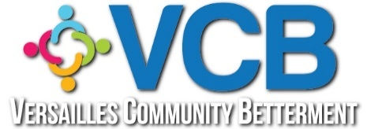

Versailles Community Betterment
Annual Board Meeting Agenda
April 29, 2024 @ 6:00PM
Morgan County Library

- Call to Order --- 6:00PM Curtis
- Pledge of Allegiance --- Prayer
- Treasurer’s Report/emailed previously/Corrections and Approval
- Meeting Minutes/emailed previously/Corrections and Approval

- New Business:
  - Our website/Facebook manager, Stefanie LaFoy, has asked for a backup person to learn the programs, passwords and renewal information. Shawna Evans has volunteered to be trained and to assist as needed. Vote.
  - Our committee names: Residential Beautification and Commercial Beautification would like to be renamed to drop the word “Beautification” on both titles: Residential and Commercial would be the new committee titles. Vote
  - Missouri Community Betterment annual conference will be held in Jefferson City in October this year. We need a person/committee to secure our silent auction contribution. We authorized up to $150 for it last year.
Need person/committee. Need budget amount to spend.

- Sub-committee Reports:

  - Residential, Dani
  - Commercial, Becky C
  - Youth, Tony

- Other business:

  - Curtis Cunningham has graciously served our VCB board as president since October, 2023. We appreciate his leadership and volunteer heart in helping us through this time period. Stefanie LaFoy has agreed to and has been voted in as our next VCB president to serve now through January, 2025 and hopefully many years beyond.
Thank you, Curtis!!! Welcome Stefanie!!!
  - Laura Coons will now assist in updating our signature cards at The Bank of Versailles with the executive board.

- Next meeting date –July 29, 2024

- Adjourn

