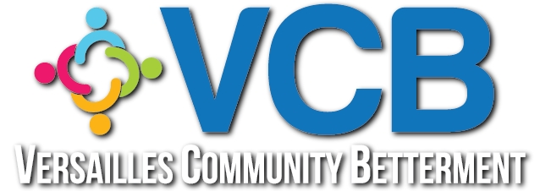

Versailles Community Betterment
Annual Board Meeting Agenda
January 29, 2024 @ 6:00PM
Morgan County Library

- Call to Order - 6:00PM Curtis
- Pledge of Allegiance --- Prayer
- Treasurer’s Report/emailed previously/Corrections and Approval
- Meeting Minutes/emailed previously/Corrections and Approval

- New Business:
  - Dani Campbell has accepted the Residential Beautification Chairman position and will lead that committee with Coummunity Partner Weeks as the primary committee focus and will coordinate with 3MT each year. Welcome to the VCB
board, Dani!
  - Cindy Davenport and Elva Clark’s terms are complete as Advisories on the VCB board. We thank them so much for their service!
  - Ann Black, Tony Coons and Becky Callaghan have agreed to another term on the VCB Board. Thank you!!
  - Amy Siler has agreed to serve as an Advisory on the VCB board. Vote.

- Sub-committee Reports

  - Residential Beautification, Dani
  - Commercial Beautification, Becky C
  - VCB Youth, Tony

- Other business

  - The high school group raising money for the ALS Foundation has asked if we’d like to contribute cookies again. All proceeds go to the ALS Foundation. Their fundraiser will run through May, 2024. They sell cookies, “Cookies for Chuck”, to honor Chuck Pryor, during all home boys basketball games and other school events. They have set up a bank account at Citizens Bank, titled: “Versailles Student Charities.” There are 5 home games in February. Sign up sheet for cookies to be delivered on Feb 5th, pass around.

- Next meeting date –April 29, 2024
- Adjourn

